 **Shri Ramdeobaba College of Engineering & Management, Nagpur 13**

**Department of Electronics Engineering**

**Instrumentation and control lab (ENP354)**

Semester: V Session: 2023-24 Section: A Batch: A-2

## *************************************************************************************

Name of Student: Tanay Darode Roll Number: A-23

Date of performance of Experiment: 05/10/2023 Date of Submission of Experiment file: 12/10/2023

*************************************************************************************

# EXPERIMENT NO. 3

**Aim of Experiment:** - Measurement of Light Intensity using light sensor.

**Objective of Experiment:** - Measure the light intensity on the surface area.

**Tool used: -** Arduino, Bread Board, Sensor, power supply, Light Dependent Resistor, Lux Meter, LED with known power, Connecting wires, Laptop/Computer system

***************************************************************************************************

**Intensity** is the ratio of power to unit area. Light power is measured in Watts, so, in physics, light intensity is measured in Watts per square meter.

Illuminance is the metric that is used to measure the light intensity within a space. Light intensity is measured in footcandles or lux – it is the amount of light (lumens) falling on a surface (over any given square foot or square meter). Therefore, light intensity is measured in terms of **lumens per square foot (footcandles) or lumens per square meter (lux)**.

**Lumens (lm)** are the unit of measurement we use to quantify the amount of visible light the human eye can see. The luminous flux of a particular light source is measured in lumens.

**Lux** is simply the unit of measure used to describe the number of lumens falling on a square foot (footcandles) or square meter (lux) of a surface. So, let’s say you have a light source with 1,000 lumens. If all of those 1,000 lumens are spread over a surface area of 1 square meter, you’d have an illuminance of 1,000 lux – i.e., the brightness of an overcast day. But what if we spread this over 10x the area i.e., 10 square meters? Well, the illuminance or lux would decrease to a less intense and dimmer 100 lux. We use the same approach for footcandles, only our units are lumens per square foot.

A **footcandle** is a measure of light intensity – it’s the number of lumens per square foot.

Luminous flux is how to measure the perceived power or total amount of light output from a light source. When the number of lumens – the unit-amount of visible light a human eye can see, is used to measure the intensity of a light source. A one-meter sq. surface area is required (lux) to determine the luminous flux value.

Examples of common light levels:

* Bright Summer Day: 100,000 Lux (~10,000 footcandles)
* Full Daylight: 10,000 Lux (~1,000 footcandles)
* Overcast Day: 1,000 Lux (~100 footcandles)
* Traditional Office Lighting: 300-500 Lux (30-50 footcandles)
* Common Stairway: 50-100 Lux (5-10 footcandles)
* Twilight: 10 Lux (1 footcandle)
* Full Moon: <1 Lux (<0.1 footcandle)

One of the ways to measure light with an Arduino is with an LDR. LDR’s (Light dependent resistors) have a low resistance in bright light and a high resistance in the darkness.

The general formula for intensity is I = P/A where I stands for intensity, P stands for power, and A stands for area. Power and area are measured differently for different quantities, so intensity is measured differently depending on the type of quantity being studied.

Calculating light intensity at a particular point involves following steps:

1. This calculation is slightly more difficult than other calculations involving light because there are several different ways to evaluate light intensity. The light intensity at a particular point depends on the configuration of the light source and the directions in which it radiates light. The simplest example of calculating light intensity deals with the intensity of light around a bulb that radiates light equally in all directions.
2. Find the wattage of the bulb. Your lab worksheet may give you this information or you may have to find it yourself. The wattage is usually printed on the bulb.
3. Measure the distance between the light source and your point of interest. Use metric measurements.
4. Convert the distance that you measured into meters. For example, if the point at which you want to calculate the light intensity is 81 cm away from the light source, report your answer as 0.81 meters. This value represents the radius of a sphere surrounding the bulb.
5. Square the value from Step 3. You will use this number to calculate the surface area of the sphere. The surface area of a sphere is equal to 4(pi)r2. In this example, squaring the radius of 0.81 meters gives you

0.656.

1. Multiply the answer from Step 4 by 4. In this example, multiply 0.656 by 4 to get 2.62.
2. Multiply your answer from the previous step by pi. This answer is the surface area of your relevant sphere of light intensity. In this example, multiply 2.62 by pi to get 8.24. If you have a scientific calculator, use the pi key to do this problem. If you are using a four-function calculator, you can approximate pi as 3.14.
3. Divide the bulb's wattage by the answer from the previous step. This final answer is given in watts per meters squared. This answer tells you that the light intensity at your point on the sphere is equal to the number of watts that the bulb radiates divided by the surface area of the sphere. If you had a 60-watt bulb in the center of this sphere, you would divide 60 by 8.24 to get 7.28 watts per meters squared as the light intensity at your point of interest.

## Light Meter

* RNS ID: RS030702
* Brand Name: Meco
* Part Number: 930
* Type of Product: Light Lux Meter
* AC Current Range: 0.4 to 20m / s, 80 to 4000 ft / m
* Resistance Range (Ohm): -20°C to 60°C, -4°F to 140°F

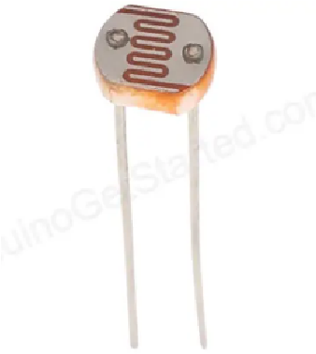

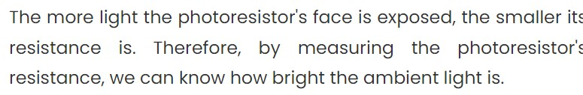

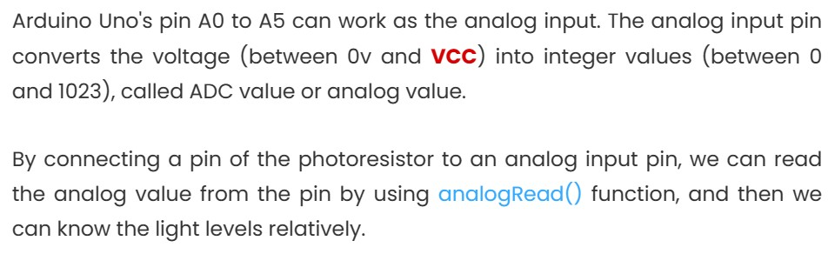

**Wiring – Connecting Light sensor to Arduino**

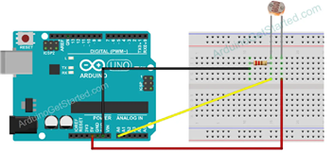

**Observation: -**

|  |  |
| --- | --- |
| Intensity (LUX) | Voltage (V) |
|  |  |
| 0.266 | 2.82 |
| 0.722 | 2.74 |
| 1.402 | 2.14 |
| 2.306 | 1.57 |
| 2.616 | 1.36 |
| 4.441 | 0.99 |
| 6.301 | 0.69 |
| 9.01 | 0.51 |
| 15.57 | 0.31 |
| 20.371 | 0.23 |
| 50.841 | 0.11 |

**Result: -**

**Conclusion: -** From this experiment we observed that as the darkness increase LDR increases the resistance of itself and intensity of light will decrease. Resistance of LDR and intensity of light is indirectly proportional to each other